

User’s Manual for the Havasu River Riverine Environmental Flow Decision Support System (REFDSS),

By Colin Talbert

Open-File Report 2015–XXXX

U.S. Department of the Interior

U.S. Geological Survey

U.S. Department of the Interior

SALLY JEWELL, Secretary

U.S. Geological Survey

Suzette M. Kimball, Acting Director

U.S. Geological Survey, Reston, Virginia: 2015

For more information on the USGS—the Federal source for science about the Earth,  
its natural and living resources, natural hazards, and the environment—visit   
<http://www.usgs.gov> or call 1–888–ASK–USGS

For an overview of USGS information products, including maps, imagery, and publications,  
visit <http://www.usgs.gov/pubprod>

To order this and other USGS information products, visit <http://store.usgs.gov>

Any use of trade, firm, or product names is for descriptive purposes only and does not imply   
endorsement by the U.S. Government.

Although this information product, for the most part, is in the public domain, it also may contain  
copyrighted materials as noted in the text. Permission to reproduce copyrighted items must be   
secured from the copyright owner.

Suggested citation:  
Talbert, Colin, 2015, User’s manual for the upper Havasu riverine environmental flow decision support system (REFDSS): U.S. Geological Survey Open-File Report 2015–XXXX, XX p., <http://dx.doi.org/10.3133/ofr2014xxxx.>

ISSN 2331-1258 (online)

**Contents**

Installation and Configuration 5

Application Installation 5

Obtaining the Input Data 6

Using the REFDSS 8

Adding, Removing, and Resizing Modules 9

Using Views to Facilitate Organizing Multiple Modules 10

REFDSS Toolbars 11

Map Controls Toolbar 11

Chart Controls Toolbar 12

REFDSS Map Modules 13

Segment Map 13

Map Legend 14

Habitat Suitability Generator 15

Scenarios 17

Adding and Removing Scenarios from the DSS 17

Chart Output Modules 18

Change the Displayed Data in a Single Chart 18

Change Individual Series Symbology and Label 21

Format a Chart 21

Hydrograph Module 22

Summary Habitat Results 23

Flow Versus Habitat Chart 24

Tier 1 data 25

Figures

**Figure 1.** Download data option screen 7

**Figure 2.** Module being moved and docked 10

**Figure 3.** Map controls toolbar 11

**Figure 4.** Chart controls toolbar 12

**Figure 5.** Segment map module 13

**Figure 6.** Map legend module 14

**Figure 7.** Habitat suitability generator module 16

**Figure 8.** Select data window. 19

**Figure 9.** Format series 21

**Figure 10.** Hydrograph chart 23

**Figure 11.** Summary habitat chart. 24

**Figure 12.** Flow habitat chart 25

**Figure 13.** Adding a Tier 1 figure. 26

Tables

**Table 1.** REFDSS modules. 7

**Table 2.** Havasu REFDSS built-in module views 9

User’s Manual for the Havasu River Riverine Environmental Flow Decision Support System (REFDSS)

By Colin Talbert

# Installation and Configuration

## Application Installation

Installation of the Havasu REFDSS requires a two-step process. The components required for both steps are available from the USGS ScienceBase Catalog at <https://www.sciencebase.gov/catalog/folder/55ad8535e4b066a2492421ab>. The first step is to install the open source mapping library called MapWinGIS, which is used by the application. This requires administrative privileges and is accomplished by downloading and running the “[MapWinGIS 4.8 installer](https://www.sciencebase.gov/catalog/item/55ad8994e4b066a2492421ae)” component available from the ScienceBase folder link above. The next step is to download and install the “HavasuREFDSS installer” from the same folder. This second step does not require administrative privileges. For both steps all default installation options should be fine.

Because of the heavy computational demands inherent in the methodology, a 64-bit computer is required. Most new computers are 64-bit, but there are still 32-bit systems in use. You will need to have at least 20 gigabytes (GB) of hard drive storage space available on the computer to store the inputs and derived data required by the application. This data storage space can be located on an external or network drive as well.

## Obtaining the Input Data

Installation of the application as described in the previous section does not provide the input data required by the DSS. The first time you open the REFDSS application, a form will pop up alerting you that the input data wasn’t found and providing options for obtaining it (Figure 1). The Auto download option is recommended for most first-time users. This is accomplished by clicking the “Download Initial Data” button and selecting a folder to save the data in. A progress bar will appear as the data is downloaded from ScienceBase and extracted. Once this finishes the application will open automatically.

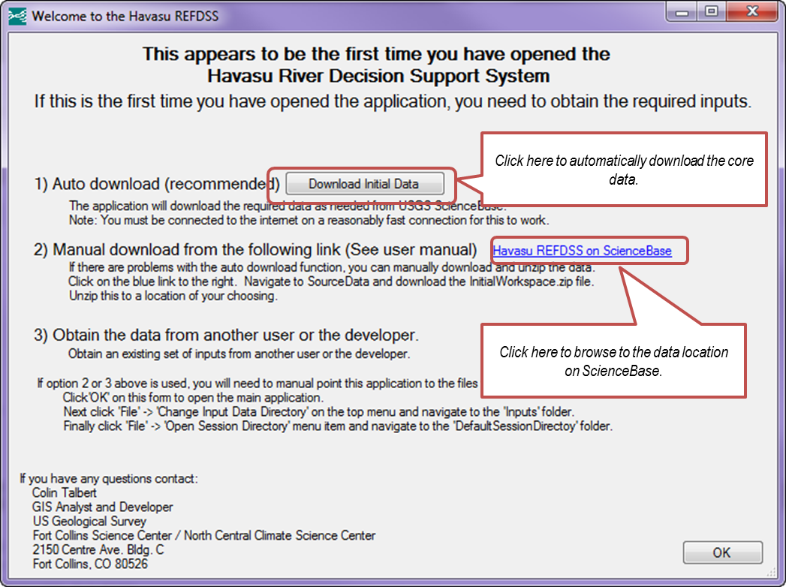

1. Download data option screen

The second, optional, method of obtaining this core data is to manually download the required data directly from ScienceBase at https://www.sciencebase.gov/catalog/item/55ad587be4b066a249242180 , which can also be navigated to by clicking on the ScienceBase link on the above form (figure 1). All of the data needed by the application are in a zipped bundled called Full.zip which can be found by clicking the SourceData folder from the above site and then clicking on the InitialWorkspace.zip item.

The third method is to obtain the data directly from another user or the developers of the application. This might be the best or only option for users that do not have a reliable or high-speed internet connection.

With either of these last two options, click “OK” on this form to dismiss it and open the actual application. Then in the top menu click “File” and select “Open Session Directory” and navigate to the “DefaultSessionDirectory” subfolder in the unzipped data obtained in the previous two steps.

# Using the REFDSS

The REFDSS application is set up in a modular manner to allow flexibility in the content displayed at any time. Currently, there are seven different modules in the application (table 1). Each module consists of an independent window configured for viewing a specific type of data or summary. When using the application, any number of modules can be used at any time. Each module is independently configurable, resizable, and moveable. While each open module is independent, they do interact to facilitate data exploration. For example, moving the cursor on a hydrograph and clicking once will update the maps to display the selected water surface elevation (WSE). If the user does not want an individual module updated relative to other modules, the user can lock individual modules by right clicking anywhere on the module and selecting “Lock.” Locked modules are denoted with an asterisk (*) after their name. Each module will be described in detail in subsequent sections.

1. REFDSS modules.

|  |  |
| --- | --- |
| Module | Description |
| Segment Map | Map display of spatial data |
| Map Legend | Display color legend for an individual map |
| Habitat Suitability Generator | Used to view and modify the habitat suitability criteria used in the REFDSS. Also used to regenerate the spatial habitat map output |
| Hydrograph | Chart of the daily water surface elevation (WSE), habitat, or other metrics |
| Summary Habitat Results | Chart of available habit across the period of record. Also used to identify scenarios that deviate more than 10 percent from the baseline scenario |
| Flow Versus Habitat Chart | Chart of the normalized habitat versus water surface elevation functions |
| Tabular Data | Spreadsheet of the data used to create any of the charts or non-spatial inputs |

## Adding, Removing, and Resizing Modules

New modules can be added to the application through use of the “Modules” menu. The selected module will appear with the default size and docking (right, left, top, or bottom). A module can be resized by hovering the cursor over one of the edges; when the resize icon appears, the user can click and drag the module to the desired size. A module can be moved by clicking and dragging the title bar of that module to a new position. While the module is being dragged, a set of docking icons will be visible as well as a ghost-blue image of the module’s new location (figure 2). Modules can be removed by clicking on the X in the upper right corner. In addition to the basic docking locations within the application, users can also dock modules within other modules, drag modules outside the main application window, stack multiple modules onto one another, and pin modules so they auto hide when not in use.

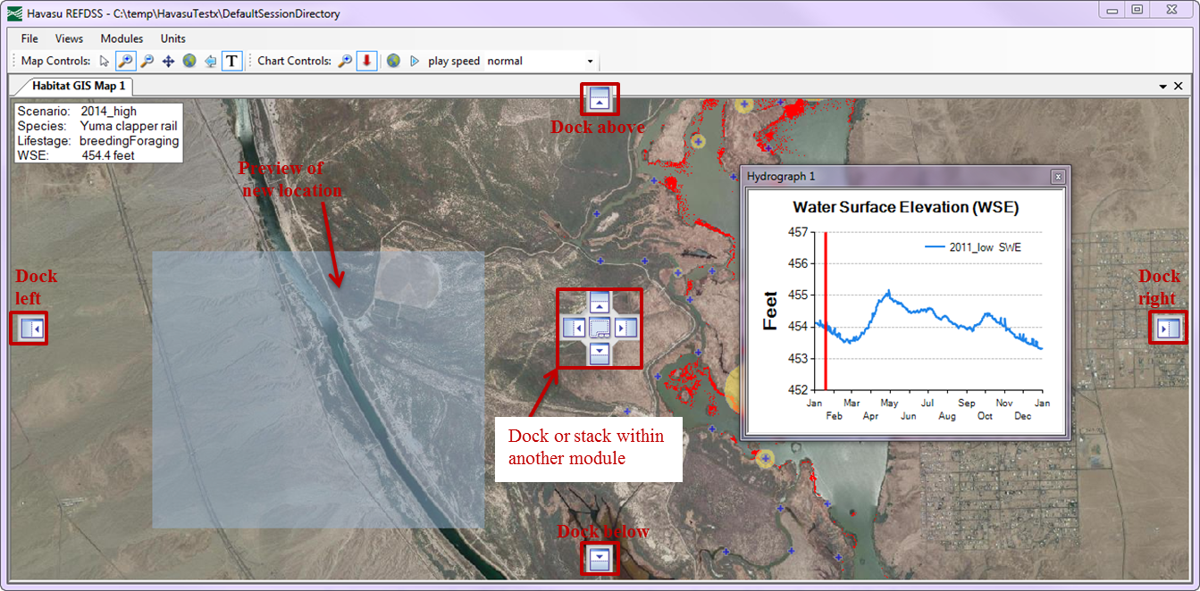

1. Module being moved and docked

## Using Views to Facilitate Organizing Multiple Modules

The user will most often interact with multiple modules at once in the REFDSS. While it is possible to bring in and set up multiple modules individually, the REFDSS provides the ability to easily open, switch between, and save views. The REFDSS comes with several built-in views that users can select to open a specific module configuration. Built-in views (table 2) can be selected using the “Views” menu. User-defined custom views can be saved by clicking the “Views” menu and selecting “Save current view.” The user will then be prompted to name the new view. “Remove view” is used for deleting a no longer needed view. Be careful when removing views as the view, even the built-in view, is permanently deleted.

1. Havasu REFDSS built-in module views

|  |  |  |
| --- | --- | --- |
| View | Description | |
|  |  | |
| Habitat vs WSE Curves | | Display of how the area of habitat for the three focal species changes across a range of marsh elevations |
| Edit Habitat Suitability | | View or edit the habitat suitability curves (HSC) and run habitat recalculation. |
| Summary Habitat Results-All Scenarios | | Summary of habitat and water requirements for all scenarios. |
| Water Storage Historic Comparison | | Comparison of water storage and requirement for historic scenarios. |
| Water Storage Hypothetical Comparison | | Comparison of water storage and requirements for hypothetical habitat driven scenarios. |

# REFDSS Toolbars

Three toolbars are docked at the top of the REFDSS application that can be used for interacting with various modules. The “Map Controls” toolbar is used to manipulate the map modules; the “Chart Controls” toolbar is used to manipulate the various output charts.

## Map Controls Toolbar

The Map Controls toolbar contains various items useful for interacting with the map modules (figure 3). The first four icons change the type of interaction and cursor the mouse has with the map. Users of online mapping or GIS will be familiar with these icons. The next two icons are used to either zoom to the full extent or the previous extent. The last icon will turn on or off the maps title box.

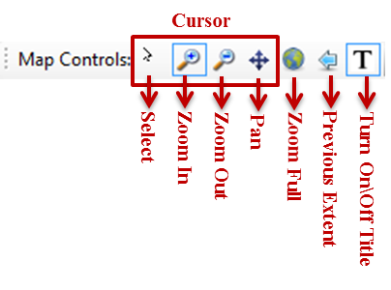

1. Map controls toolbar

## Chart Controls Toolbar

This toolbar contains items specific to the various chart modules (figure 4). The first two items change the type of interaction/cursor that the mouse has with charts. The “Zoom In” cursor is used to display a section of the chart in greater detail. This can be done by selecting the “Zoom In” button and then clicking and dragging over a section of a chart to make that subset of the data fill the chart area. The “Select” cursor is specialized to only work on the hydrograph chart modules. Clicking on a point in the hydrograph with the “Select” cursor will update a corresponding segment map based on the nearest representative flow/Water Surface Elevation (WSE) used in the DSS. This can be used to determine how input covariates and output habitat change across a range of flows. The final two items on the Chart Controls toolbar allow the user to play a time-lapse animation of the map display showing the changes in response metrics to the hydrograph values. The view named “Edit habitat suitability” is set up to provide a demonstration of this selection and animation. If the user opens this view and clicks on the hydrograph, the maps update to display layers corresponding to the selected flow. Clicking the “Play” button allows the user to view the animation; clicking “Play” again stops the animation.

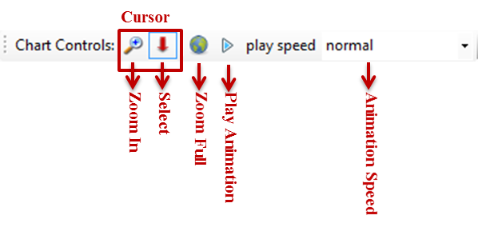

1. Chart controls toolbar

# REFDSS Map Modules

## Segment Map

The Segment Map module provides a means of viewing a detailed map for an individual study segment. On top of an aerial image of the segment, the user can display one of the covariates or outputs. To change either the study segment or the overlaid map layer, right click on the map or its title bar and a context menu will appear. Hover your mouse over the scenario, segment, time period, species, life stage, covariate, or flow that you are interested in viewing. The list of available items under that category will appear (figure 5). To display or remove the title box, click the “T” icon on the map toolbar.

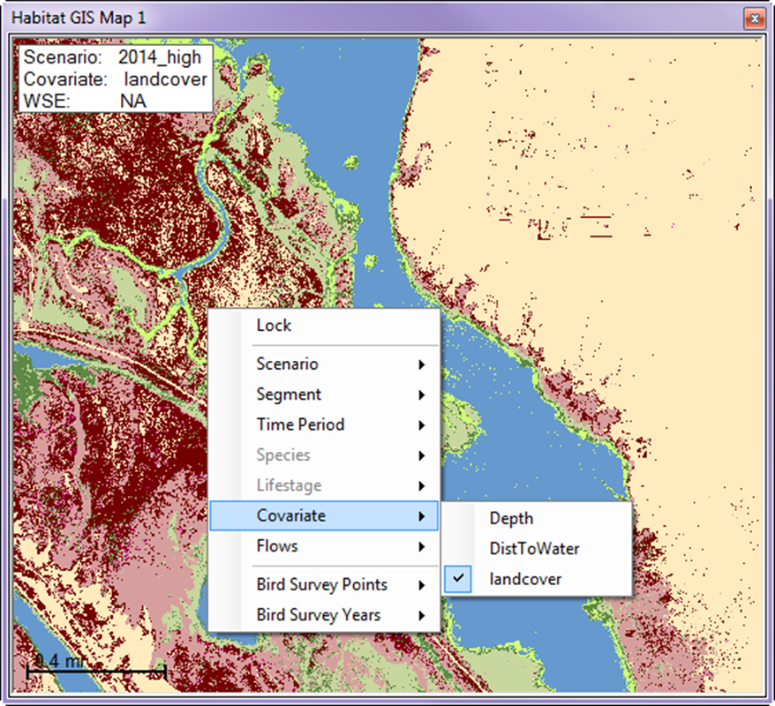

1. Segment map module

## Map Legend

The Map Legend module is used to show what the colors on a segment map signify. After adding a map legend module you will need to change the display to match the variable of interest by right clicking in the module and selecting from the list that pops up. For clarity you will probably want to dock the module next to its corresponding segment map and resize it to be fairly narrow. Note that the color ramp being display only corresponds to the default ramp for each variable, if you are modifying the HSC values the colors displayed on the segment map will correspond to the values and colors shown in the Habitat Suitability Generator module (described below).

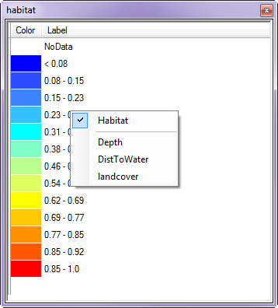

1. Map legend module

## Habitat Suitability Generator

The Habitat Suitability Generator module provides functionality to view and change the HSC used to generate habitat maps for the REFDSS. Additionally, it allows the user to view and edit the equation used to generate the habitat maps. It also contains functions to regenerate the map outputs when changes to the habitat suitability curves (HSCs) or equations have been made (figure 7). The default HSC values that are delivered with the DSS are currently undergoing literature verification and may be modified in the future as more data become available.

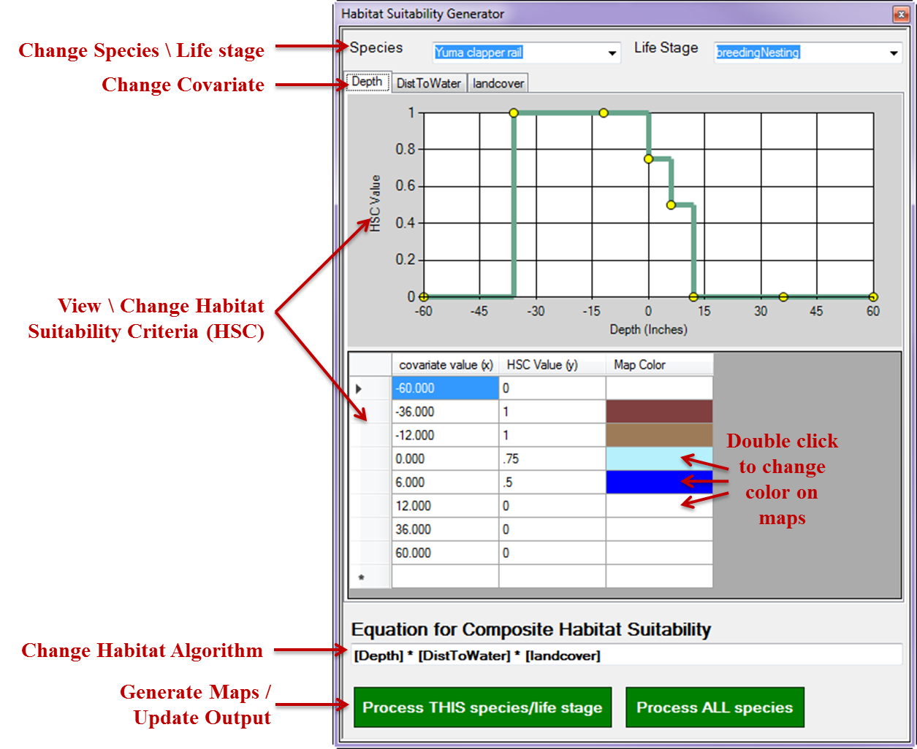

1. Habitat suitability generator module

In the center of this module, there is a chart that displays an HSC curve for a single species, life stage, and covariate. Beneath that curve is a list of its x and y values. Edits to the curve can be made by either changing the values in the table or clicking and dragging on one of the yellow dots on the curve chart. The drop-down boxes at the top of the module can be used to change the species or life stage HSC displayed. To switch between different input covariates (e.g., depth and DistToWater), select the tabs immediately above the chart. Any changes to the HSC are automatically saved, replacing the original values. To undo these changes and revert to the original HSC values, click “File” and select the “Reset Habitat Suitability Curves (HSCs)” option.

If a segment map module is visible, any changes to the HSC will be reflected in the spatial habitat inputs. To try this, open the “Edit habitat suitability curves/maps” view. Change one of the HSC values in either the chart or table to get the segment map modules to update their display. The three segment map modules are displaying depth, distance to water, and velocity using the default symbology for those layers. The third column in the table below the HSC chart shows the color that will appear on the map for that portion of the HSC. Double click on the colored box to change this color. White indicates areas that will be displayed as transparent on the map.

Once all changes to the HSC have been made, the user can update the equation used in the text box entitled “Equation for Composite Habitat Suitability.” Standard mathematical symbols can be used with the covariates contained in square brackets. For example, the default algorithm for brown trout spawning (after Bovee and others, 2007) is “[Depth] * [Velocity].” This means that the depth grid (or map) will be reclassified according to the depth HSC and then multiplied by the velocity grid and reclassified according to the velocity HSC. If the user wanted to change this algorithm to be the square root of (depth squared * velocity squared), for example, the equation would be entered as “([Depth]^2 * [Velocity]^2)^0.5)”.

Once the equations have been set, the outputs can be regenerated. To process the outputs for a single species/life stage, click the “Process THIS species/life stage” button. The processing time for a single species depends on the computer’s speed and memory but should be around 20 minutes. To reprocess all of the species and life stages, click the “Process ALL species” button. The processing time for all species takes considerably longer, somewhere around four hours, as of the time of the writing of this publication.

# Scenarios

Within the DSS, scenarios represent alternate management or environmental conditions which result in a different time series of daily water surface elevations (WSEs) and/or evapotranspiration (ET). For the Havasu NWR implementation of the REFDSS framework these are limited to a single calendar year. The application starts with three historical scenarios representing an extreme low water year (2011), a high water year (2014) and scenario representing the daily average values for 2005-2014. In addition there are two scenarios representing hypothetical management options in which the marsh surface is regulated in a manner to maximize habitat for two of the species of interest, southwestern willow fly catcher and Yuma clapper rail. The last hypothetical scenario is a compromise in which attempts to simultaneously maximize the habitat for both species. For each of these hypothetical scenarios no attempt was made include account for additional requirements (water quality, recreation) or feasibility (diversion capacity). As such, these hypothetical scenarios do not represent recommendations only examples of how one might use the DSS to compare scenarios.

## Adding and Removing Scenarios from the DSS

Users will potentially want to compare new scenarios that are not included in the DSS. This can be done by creating a new scenario file and adding it to the application. To do this navigate to the Inputs subfolder at the location you specified in the obtaining inputs section above. If you don’t recall where these inputs were saved, click on File -> Change Input Data Directory from the main menu to find the path to this folder. Make a copy of one of the existing scenarios files such as wse_2011.xlsx and open this copy in Excel. Change the daily WSE values in column two and the ET values in column three. The WSE values are in meters in the NGVD29 datum. The ET values are in acre feet. Once the edits are complete save and close the file in Excel. Now back in the DSS click File -> Add Scenario and navigate to the file just created. A text box will pop up prompting you to enter a name for this scenario. Choose a new short name with no spaces and click ok. The data from the Excel worksheet will be imported into the current database. This process can take a few minutes. If you make a mistake, or want to remove some of the current scenarios click File -> Remove Scenario and select the scenario to remove from the list to the right. Be careful as there is no way to undo this removal, other than reimporting the scenario.

# Chart Output Modules

These modules, which include Hydrograph, Summary Habitat Results, and Flow Versus Habitat Chart, are used to display various outputs in a graphical or chart-based form. Each module has a context menu that can be opened by right clicking in the module or its title bar. The context menu lists several useful options including printing the chart, saving a .jpeg image of the chart, or copying it to the clipboard (for use in another application, for example).

## Change the Displayed Data in a Single Chart

The context menu (obtained by right clicking on a chart) contains an option titled “Select Data” which allows the user to change the data that the chart is displaying. Selecting this opens an interface that allows the user to select multiple items for display. This interface will be slightly different for each of the output chart modules (figure 8). For example, the scenario and baseline selection box will not be visible in a “Flow Versus Habitat Chart” because they are the same for all scenarios. When multiple items are selected in each of the categories, the total number of items displayed in the resulting chart can quickly lead to indecipherable charts. It is best to limit the number of elements in any given chart and instead have multiple charts, each with a specific item of interest.

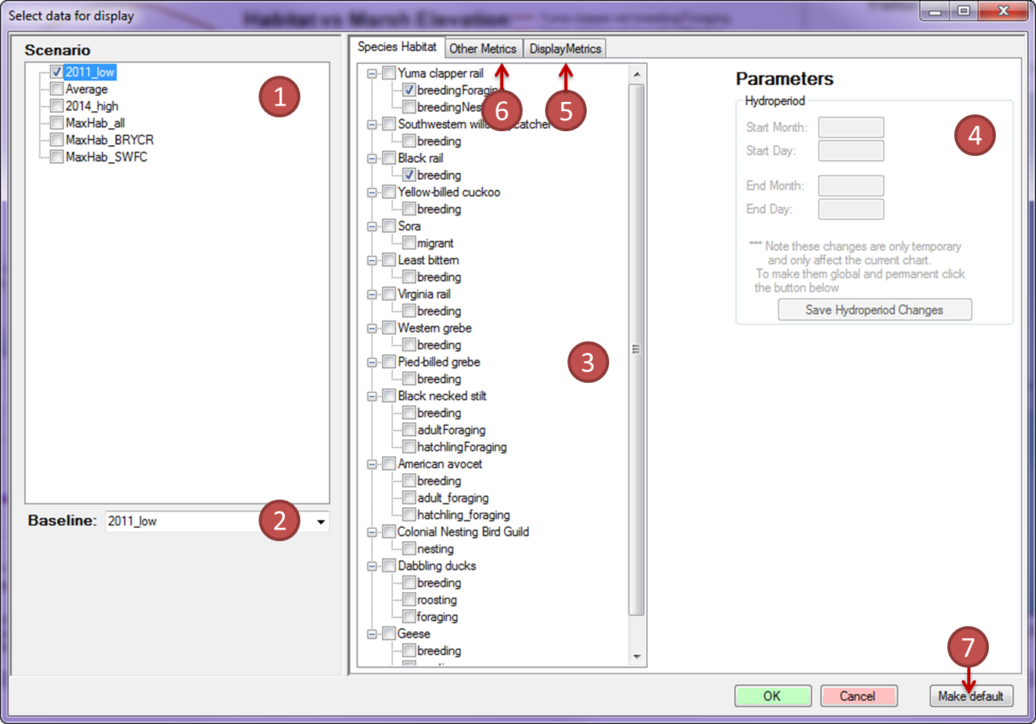

1. Select data window.

While there are numerous elements on the “Select Data window,” their use is relatively straight forward. Note that not all options will be available for selecting data for all charts.

The options are:

1. Scenario—Select which of the available scenarios to compare.
2. Baseline—Select one of the flow scenarios to be used as a baseline to compare against the remaining flow scenarios. This is used in the “Summary Habitat Chart” and the “Tabular Data” modules to measure percent change. Changes greater or less than 10% are flagged in green and red respectively.
3. Species Habitat—Specify which species/life stages will be displayed. The top level check boxes next to each species do not have an effect; there is not currently a way of summarizing across all life stages for a given species.
4. Parameters (for species habitat)—With a life stage selected, the hydroperiod parameters are enabled and display the values used for that life stage. The values in the hydroperiod boxes can be changed, but changes are temporary and only apply to the single module linked to this “Select Data” window. To make changes permanent and global, click the “Save Hydroperiod Changes” button.
5. Display Metrics—Change the aggregation algorithm used to calculate the yearly and entire hydroperiod summaries. The default value “Average of bottom 25 percent of habitat” is equivalent to what was used in the original DSS. In addition, “Minimum single habitat” in which the available habitat from the time step with the least area is reported and “Average all Habitat” in which the available habitat is averaged across all time steps in the hydroperiod are available.
6. Other Metrics – Display water storage and requirements on chart.
7. Make Default—Save the current selections to be the default for all new modules of this type.

## Change Individual Series Symbology and Label

Adjustments can be made to the color, line width, line type, and displayed title for improved chart readability. To do this, click on the series symbol in the chart legend to bring up a simple interface for changing these attributes (figure 9). These changes are saved globally so the next time users bring this series into a new chart it will have this label and symbology.

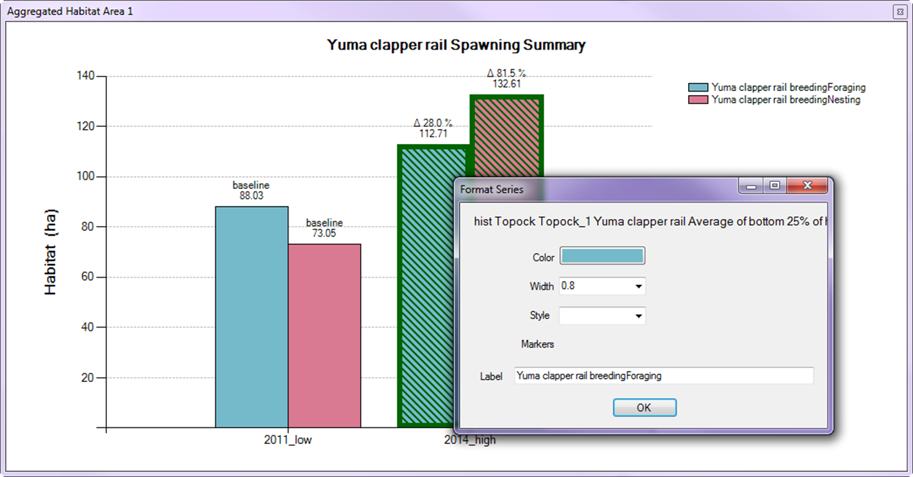

1. Format series

## Format a Chart

To change the default chart display settings, right click on a chart and select “Format Chart.” A window will appear that allows users to change the following elements: title text, title font, title location, axis labels, axis font, axis scale, tick marks, and grid lines. Much like the Select Data window, changes can be saved as the default for this chart type using the “Make default” option.

## Hydrograph Module

The “Hydrograph” module can be used to display a line graph of daily water surface elevation (WSE), habitat, or any of the other metrics. WSE series are depicted on the left or primary Y-axis while other daily series are represented on the right or secondary Y-axis. Note that when displaying multiple disparate metrics, they might not be readable on a single scale.

To zoom in on a section of the chart, click the zoom icon on the Chart Controls toolbar and click and drag a box around a section of interest. When zoomed in, users can scroll using the scroll bar at the bottom or left of the chart. To zoom back out, either double click the global extent icon on the Chart Toolbar, one of the small circles at the left end of the X-axis scroll bar or the top of the Y-axis scroll bar.

When displaying habitat areas on the hydrograph chart, only data for the time periods corresponding to the hydroperiod will be shown. These temporal extents will be highlighted with colored boxes on the chart. If a segment map is displayed and set to the same flow scenario depicted on the hydrograph, the map will sync with the selected flow. To try this, open the “Edit Habitat Suitability” view. Click Select cursor on the Chart Controls toolbar and click on the hydrograph. All three maps will update to display the habitat or covariate data for the flow that most closely matches that selected on the hydrograph. An animation of these flows over time can be viewed by clicking the “play” button on the Chart Controls toolbar.

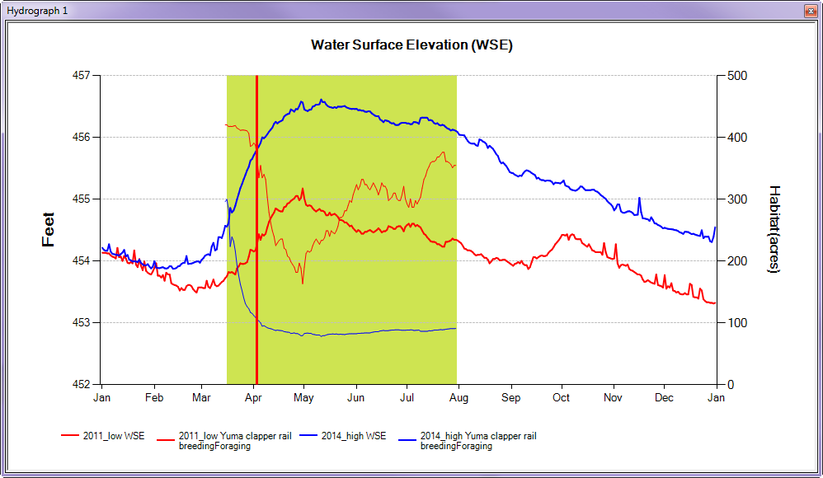

1. Hydrograph chart

## Summary Habitat Results

The “Summary Habitat Results” module presents a bar chart or boxplot of habitat area for a given species/life stage. The Summary Habitat Results chart can display output in two distinct ways. If users select “Entire Period” as the interval (under Select Data from the context menu), a single value will be displayed for each scenario. This value takes the daily values for the entire period of record and applies the selected display metric (by default “Average of bottom 25% of habitat”) to the full list at once. This is how these values were calculated in the original DSS.

The Summary Habitat Results chart allows a user to select a baseline scenario to compare the other scenarios against (using the Select Data option from the context menu). The percent change between this baseline and each chart is displayed above each bar on the chart. If one scenario performs 10 percent or more above the baseline, its bar is highlighted in green (figure 11); a decrease of 10 percent or more from baseline will be highlighted in red.

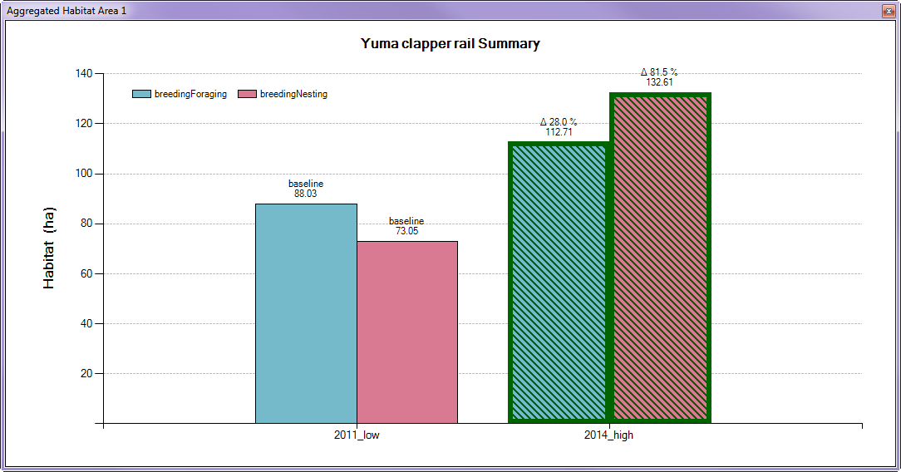

1. Summary habitat chart.

## Flow Versus Habitat Chart

The “Flow Versus Habitat Chart” module presents a means of visualizing the habitat area as a function of water surface elevation (figure 12).

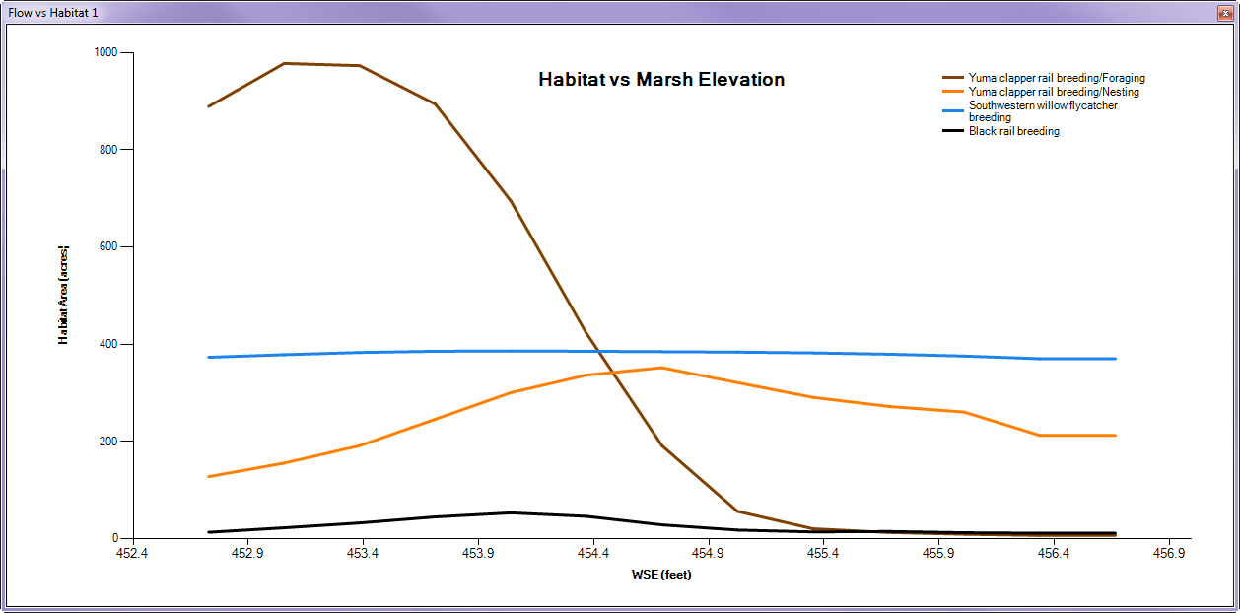

1. Flow habitat chart

## Tier 1 data

Tier 1 (water quality, aquatic species, and other) data are accessible from within the DSS using a separate dropdown menu found on the main menu bar. The tabular data, which is available in an Excel workbook file format, opens directly in Excel. Chart and image versions of these data are viewable in the DSS application in popup windows. These Tier 1 figure modules can be resized and docked in the application in same manner as other DSS modules. To change the zoom display extent use the mouse wheel to zoom in and out and click and drag on the chart image to re-center the image in the window. The save button in the upper left of the module can be used to save a copy of the image to the file system. Note that unlike other chart and map outputs in the DSS the contents of the Tier 1 figure modules are static, so the user will not be able to change the data displayed or format options such as line colors or font sizes.

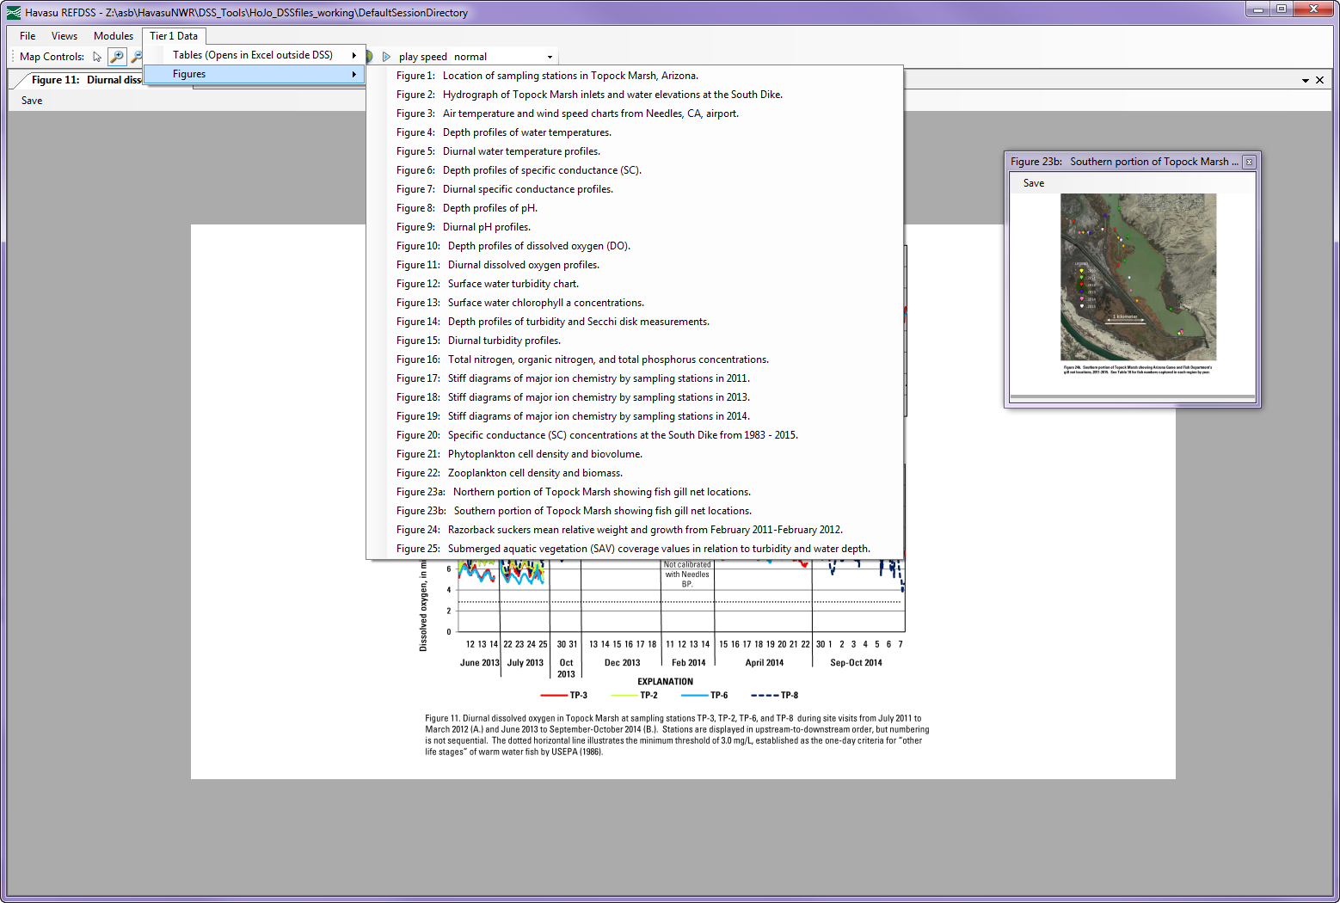

1. Adding a Tier 1 figure.

Appendix A — Credit for Open-Source Components Used

The development of the Delaware REFDSS would not have been possible without the use of several open-source and free projects.

* GIS map display is provided by the MapWinGIS ActiveX Control Project which is part of the MapWindow GIS Open Source Project (<http://www.mapwindow.org/>)
* The user configurable docking windows are from the DockPanel suite available at http://dockpanelsuite.sourceforge.net/
* The database back end uses SQLite with the dot.net bindings (<http://www.sqlite.org/about.html>)
* Unzipping functionality uses the DotNetZip Library (<http://dotnetzip.codeplex.com/>)
* Charting functionality was through the built-in Microsoft Charting Library